Solar Inverter Battery Charger
Here is an Energy saving battery charger. It harvests solar energy to replenish 12 volt Inverter battery. It has auto cut off facility to stop charging when the battery attains full charge. The charger uses a 24 volt solar panel as input.
The circuit uses a variable voltage regulator IC LM317 to set the output voltage steady around 16 volts. Variable resistor VR controls the output voltage. When the solar panel generates current, D1 forward biases and Regulator IC gets input current. Its output voltage depends on the setting of VR and the output current is controlled by R1.This current passes through D2 and R3. When the output voltage is above (as set by VR) 16volts, Zener diode ZD2 conducts and gives stable 15 volts for charging. Charging current depends on R1 and R3. Around 250 to 300 milli ampere current will be available for charging. Green LED indicates charging status. When the battery attains full voltage around 13 volts, Zener diode ZD1 conducts and T1 forward biases. This drains the output current from the regulator IC through T1 and charging process stops. When the battery voltage reduces below 12 volts, ZD1 turns off and battery charging starts again.
Solar Inverter Battery Charger Circuit
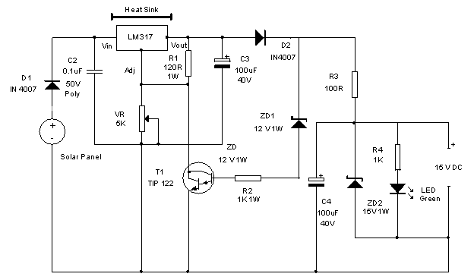
Connect the circuit to the solar panel and measure the input voltage. Make sure that it is above 18 volts. Connect the circuit to the battery with correct polarity and adjust VR till LED lights. This indicates the conduction of ZD2 and output voltage. Use heat sinks for LM317 and TIP122 to dissipate heat.
Note : The same circuit can be modified for charging different types of batteries. The only modification required is the change of ZD1 and ZD2. Select ZD2 value for the required output voltage and ZD1 for cut off voltage level. For example for 6 volt battery, ZD1 should be 6.1 volts and ZD2 6.8 volt. For Mobile battery, ZD1 should be 4.7 volts and ZD2 5.1 volts. All the other components remain same.

